**DAILY ONLINE ACTIVITIES SUMMARY**

|  |  |  |  |  |  |  |  |  |
| --- | --- | --- | --- | --- | --- | --- | --- | --- |
| **Date:** | **09/06/2020** | | | | | **Name:** | **V ANJANA PAI** | |
| **Sem & Sec** | **IV sem & B section** | | | | | **USN:** | **4AL18CS094** | |
| **Online Test Summary** | | | | | | | | |
| **Subject** | | **-** | | | | | | |
| **Max. Marks** | | **30** | | **Score** | | | **-** | |
| **Certification Course Summary** | | | | | | | | |
| **Course** | **1.Introduction to Cyber Security**  **2.Java Programming** | | | | | | | |
| **Certificate Provider** | | | **Great learning academy** | | **Duration** | | | 1. **5.5 hours** 2. **3.5 hours** |
| **Coding Challenges** | | | | | | | | |
| **Problem Statement1:** Write a C Program to rotate the matrix by K times. | | | | | | | | |
| **Status: Executed** | | | | | | | | |
| **Uploaded the report in GitHub** | | | | | **YES** | | | |
| **If yes Repository name** | | | | | **lockdown-coding** | | | |
| **Uploaded the report in slack** | | | | | **YES** | | | |

Online Test Summary: Today there was no test conducted.

Online Certification Course Summary: Today I completed Introduction to Cyber Security course by taking up the Quiz and obtained the certificate of completion. Next, I registered for the Java Programming course and learnt about the Agenda of Java Programming, what is Java and also how to install Eclipse and Java JDK. Then I also learnt about how to write a Java program and about Variables and Data Types.

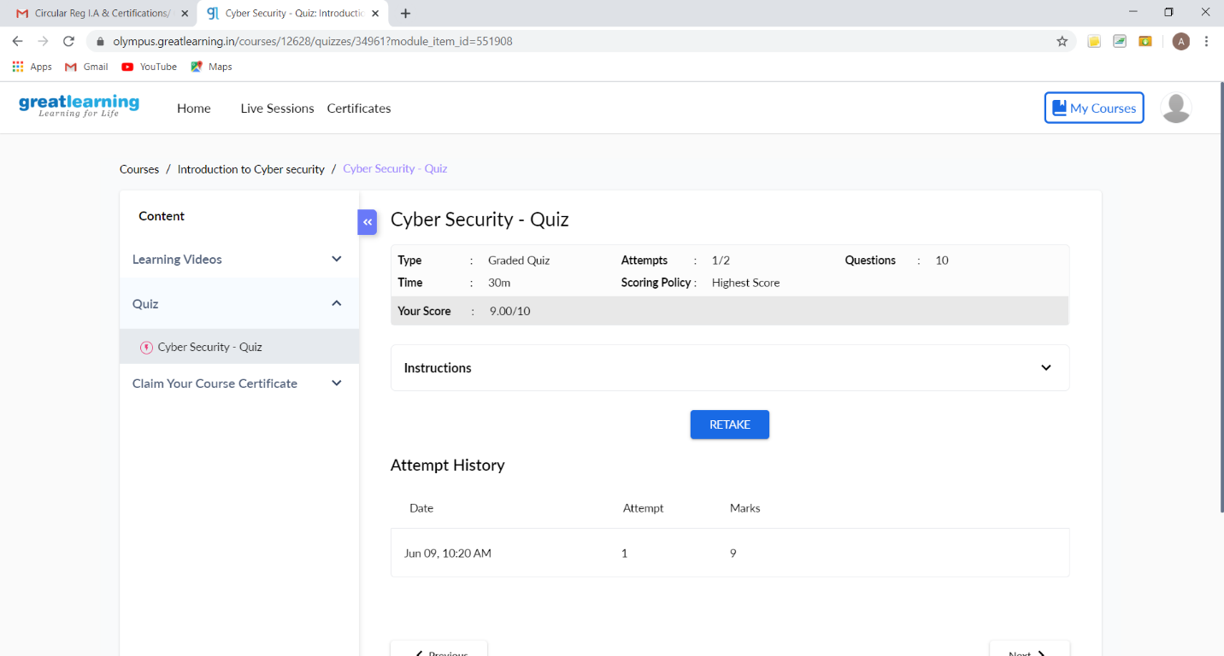

This is the snapshot of Quiz Taken.

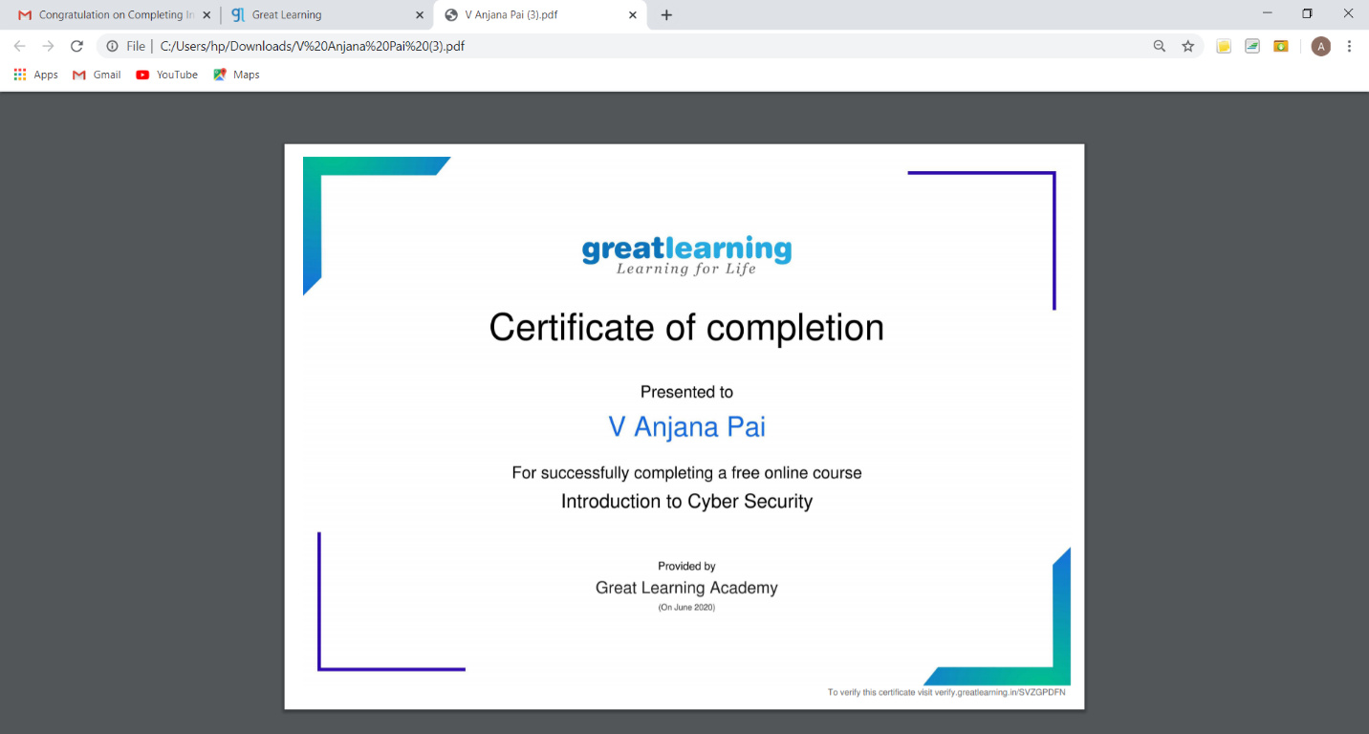

This is the snapshot of certificate obtained after the completion of Introduction to Cyber Security Course.

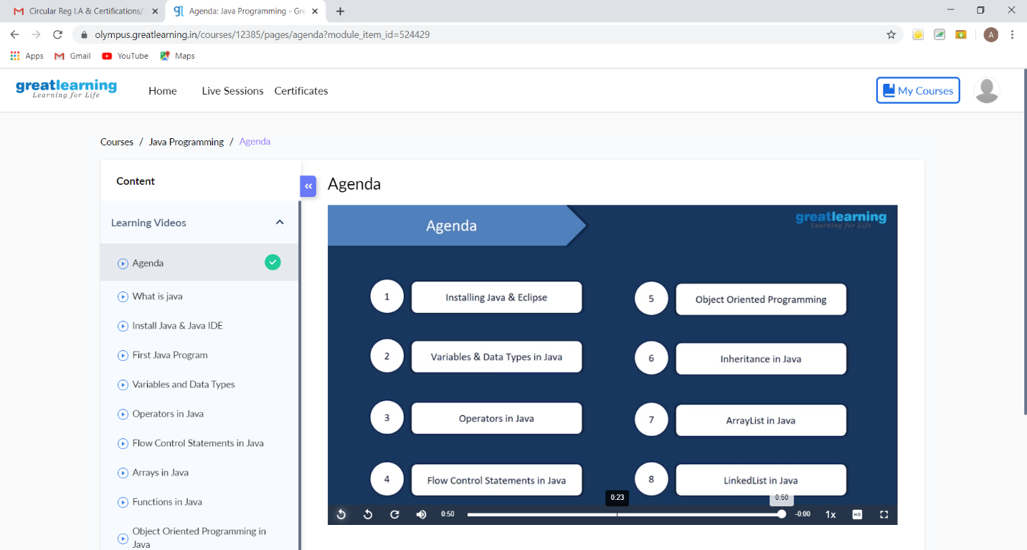

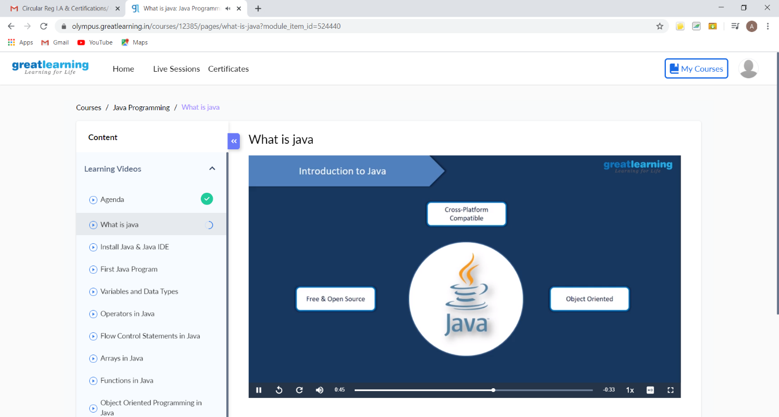

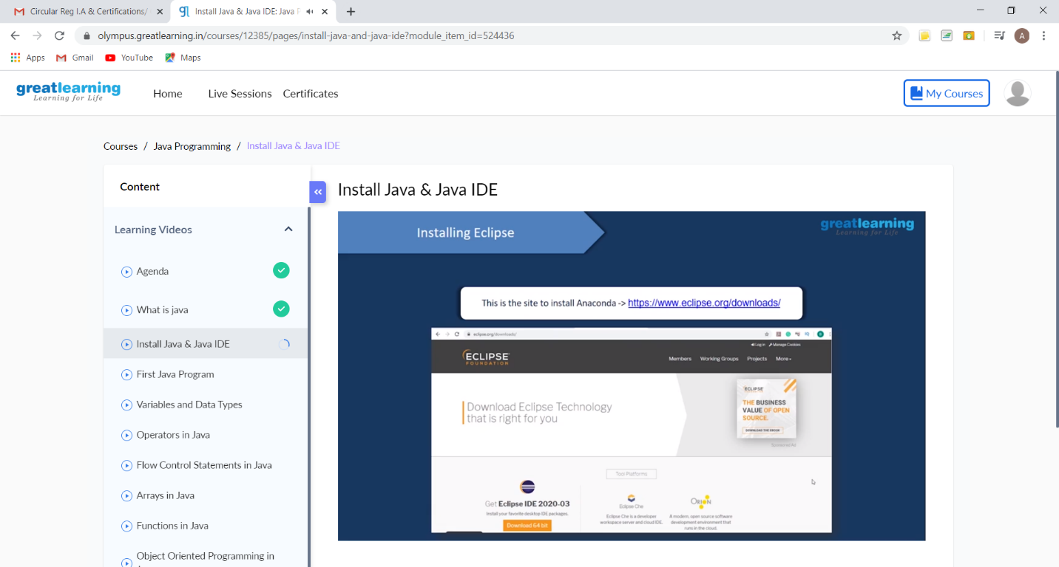

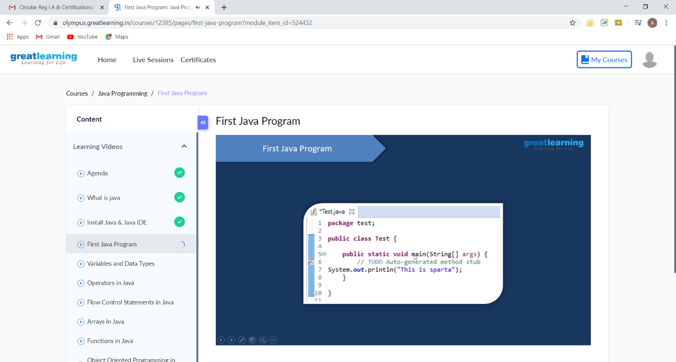

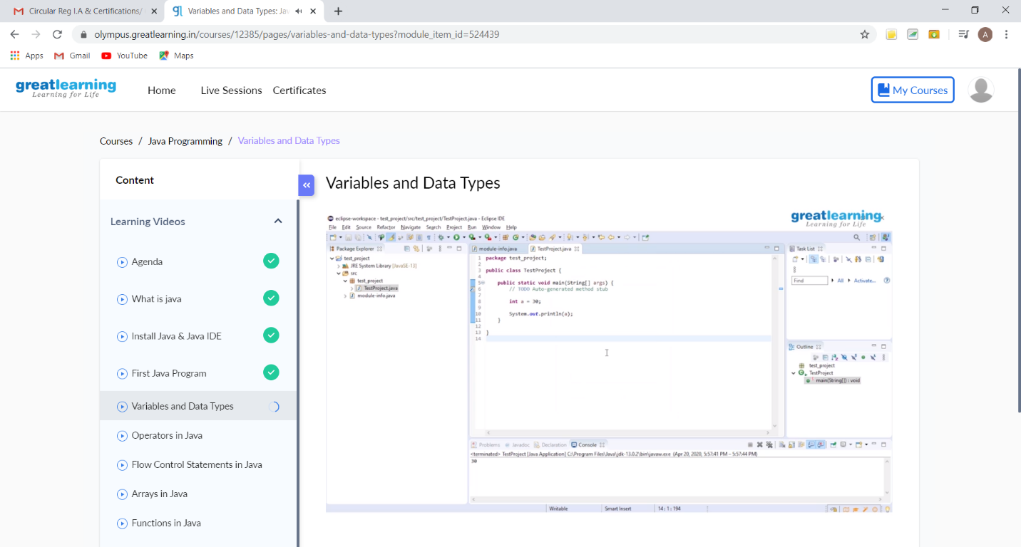

These are the Snap shots of today’s sessions.

Online Coding Summary: **Today I had received one program from prof. Venkatesh CSE Dept. The program is mentioned above in the coding challenges(pg.01). I have also uploaded it to my GitHub repository.**

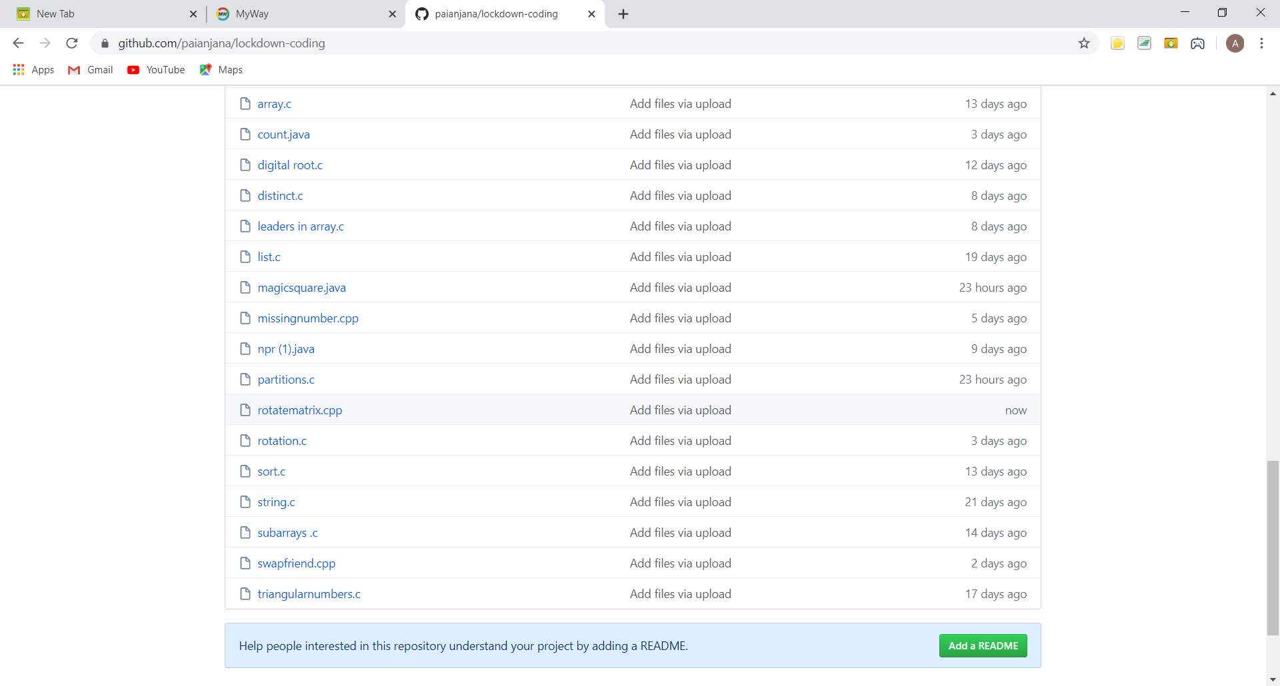

It is the snap shot of my repository where I have uploaded the code. File name is rotatematrix.cpp